Removing the Front Cover

* 1-3 (page 4)

Cable Management

* Cable Entries, Knockout Plates, Cable Fastening, Chassis Connections, 1-4 (page 8)

Fastening the Wallbox

* Preparing the Wall, A:1-2 (page 5)
* Fixing the Wallbox, B:1-4 (page 5)

Mounting DIN Rails (optional)

* Opening the Rectifiers Power Rack, A:1-2 (page 6)
* Mounting DIN Rails (optional) , B:1-3 (page 6)



Preparations

* Tools, Warnings, Block Diagram, Schematics (page 2-3)

Installing Rectifiers & Opening the Controller

* Mounting and Removing Flatpack2 Rectifiers, A:1-3 (page 7)
* Mounting and Removing Blind Panels, B:1-2 (page 7)
* Opening and Closing the Smartpack2 Master Controller, C:1-2 (page 7)

Electrical Connections

* Connecting AC Main Input, DC Output and I/O Control Signals, A:1-7 (page 9)
* Connecting the Load in 110VDC Power Systems, B:1-5 (page 10)

Check Lists

* Installation Check List
* Commissioning Procedure

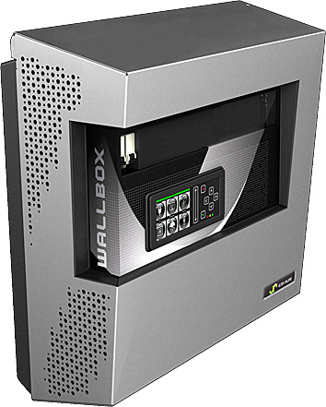

Flatpack2 PS System, Bulk Feed DC Output, Wallbox

2 Rectifiers and Smartpack2 Controller System

D = 193.5 mm

W = 452.4 mm

H = 450.3 mm

300 mm

300 mm

1000 mm

Minimum Clearances

100 mm

100 mm

**NOTICE:**

For technical **specifications and functionality description**, refer to following documents:

* CTO30210.DS3, Datasheet *Flatpack2 Wallbox*
* 350002.013, User Guide *Flatpack2* Rectifiers
* 350020.013, User Guide *Smartpack2 Master* Controller
* 350021.013, User Guide *Smartpack2 Basic* Controller
* 351509.033, Installation Guide *I/O Monitor2* CAN Node
* For generic power system functionality, refer to *WebPower Online Help* and *PowerSuite Online Help*



**CAUTION:**

* When using only one rectifier, always mount a **blind panel** in the unused position (avoids rectifier’s air cooling reduction)
* When using ***110VDC Flatpack2*** rectifiers (241115.805), always remove the DC load terminal rails — with the M8 bolts and screw terminals — and connect the load to the WDU terminal blocks



**WARNING:**

* Always **remove** the rectifiers **when transporting** the Wallbox. For dismounting instructions, refer to page 7
* When possible, **use *Flatpack2 HE*** rectifiers in the Wallbox, as they are more efficient and generate less noise. For suitable rectifier options, refer to the datasheet (CTO30210.DS3)



Warnings B:

Block Diagram C:

Tools A:

Fuse Alarm

LVD Controls

Temp. Sensors

AC Fuses,   
external

(230VAC)

**AC Supply**

(Single phase)

Flatpack2 HE  
rectifiers

CAN Bus

**DC Supply**

(24V, 48V, 60V  
 or 110V)



Ethernet cable

Internet

Smartpack2  
Master Controller



Smartpack2  
Basic Controller

Alarm Outputs NC-C-NO

Config. Inputs

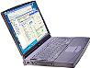

*WebPower*

(web-based  
user interface)

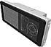

I/O Monitor2  
CAN node

***Bulk Feed   
DC Output***

*Flatpack2* System  
Wallbox

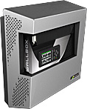

Internal

MCBs

*Telecom and Industrial*equipment

LVBD

Battery MCBs

DC Distribution   
Load MCBs



Battery Blocks

**Optional   
Equipment**



|  |  |  |
| --- | --- | --- |
| **Torque Recommendations** | | |
|  | Type & Size | Torque  (Nm) |
| T1 | Bolts M8 | 12.0 |
| T2 | Screws M5-M6 | 2.0 |
|  |  |  |
| T5 | PG21 plastic (metal) [cap nut] | 7.5 (10) [5.0] |
| T6 | PG29 plastic (metal) [cap nut] | 7.5 (10) [5.0] |
| T7 | PG36 plastic (metal) [cap nut] | 7.5 (10) [5.0] |
|  |  |  |

Note: General tolerance: ±10%

Tools

Flat 6mm



AW



PZ2



IW (Insulated)

Preparations A-D



*Flatpack2* System  
Wallbox

The figure shows the posi­tion of the relay contacts when the PS system is in alarm mode of operation; the relay coils are then de-energized (fail-safe mode). The relay out­puts are preprogrammed from factory (**Factory Settings)**.

Input Circuit 1

Input Circuit 2

Input Circuit 3

Input Circuit 4

6

Config. Input

(From external equipment)

3

2

1

4

5

Config. Input

Config. Input

Config. Input

Config. Input

Config. Input

Input Circuit 5

Input Circuit 6

+

–

+

–

–

–

+

–

+

+

+

–

**X:\*\*\***

**Programmable Inputs**

*Max. 1.5 mm2,   
(14AWG) wire section*

*I/O Monitor2 CAN Node*

Relay 1

**Common Alarm**

Alarm Circuit 1

Alarm Circuit 2

Alarm Circuit 3

Alarm Circuit 4

(To external equipment)

Alarm Circuit 5

Alarm Circuit 6

**Alarm Relay Outputs**

NO

NC

C

NO

C

NC

C

NO

NC

NO

C

NO

NC

C

NC

**X:\*\*\*\***

NO

C

NC

Relay 2

**Mains Alarm**

Relay 3

**Fuse Alarm**

**Load & Battery**

Relay 4

**High Battery Alarm**

Relay 5

**Low Battery Alarm**

Relay 6

**Rectifier Alarm**

*Max. 1.5 mm2,   
(14AWG) wire section*

+

4

3

2

1

5

6

**X:\*\***

−

**Configurable Inputs**

Temp Sense 1

+

−

Temp Sense 2

+

−

Temp Sense 3

Temperature Sensor 1

Temperature Sensor 2

Temperature Sensor 3

*Smartpack2 Basic* controller

|  |  |  |
| --- | --- | --- |
| FUNCTION | SIGNAL | PIN-OUT |

(These multipurpose inputs may also be used as digital inputs, e.g. for SPD monitoring)



*Cable Lugs for M8 bolts: Diam. 8.5mm, Max. 10.5mm*

(Not used in 110VDC systems)

Bulk Feed DC Output

Load Circuit

*Wire Section:  
35 mm2, (1AWG) screw terminals*

(Not used in 110VDC systems)

*10 mm2, (6AWG) WDU terminals*

(Only used in in 110VDC systems)

—

+

Terminal Rails and   
WDU terminals

|  |  |  |
| --- | --- | --- |
| FUNCTION | SIGNAL | TERM. POINT |

*Max. wire section  
L&N: 35 mm2 (1AWG)  
 PE: 10 mm2 (6AWG)*

PE

AC Mains Input

(Protective Earth)

AC Mains Cable

PE

N

L

F1

F2

32 A

Schematics D:

A-D Preparations

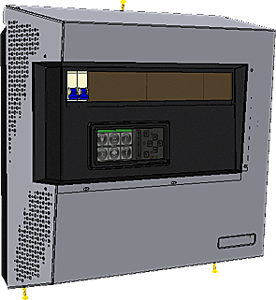

2



1



PZ2

(T2)

ccw

Wallbox

(front)

5 mm

5 mm

10 mm

ccw

PZ2

(T2)

**S1**

**S1**, **S2**, **S3** = M5 x 20 mm

**S2**

**S3**

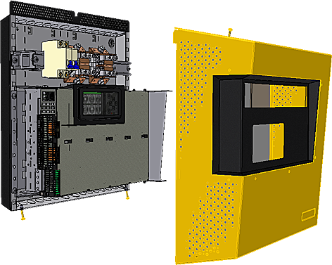

**S2**

**S1**

3

Wallbox’s Front Cover

Removing the Front Cover 1-3



**NOTICE:**

* Use **suitable screws** or bolts (not included) to fasten the Wallbox to the wall or support surface (wall plugs, expansion bolts or molly bolts)



**CAUTION:**

* The wall or support surface must be **capable of supporting** the equipment
* Check min. clearances for **Wallbox access**:   
  front access, 100 cm; top and bottom access, 30 cm; access at the sides, 10 cm



Diam. 8.5 mm

Diam. 5.5 mm

Keyhole



**WARNING:**

* **Never** mount the Wallbox in the vicinity of heaters or **above heat sources**



Get ready suitable screws or bolts (4x)  
 S4, S5, S6, S7

1

388 mm

356 mm

356 mm

388 mm

(2x)

Mark and drill 4 suitable holes in the wall

2

3



PZ2

cw



S4

S5

|  |  |  |  |
| --- | --- | --- | --- |
| **Weight** | | | |
| Parts | Kg | Pcs | Kg |
| FP2 WB ex Rectifiers |  |  | 11.3 |
| FP2 Rectifier | 1.95 | 2 | 3.9 |
|  |  |  |  |
| **Total weight FP2 WB** |  |  | **15.2** |

Note: General tolerance: ±10%

Suitable screw or bolt, S5 (2x)

(2x)



3 mm

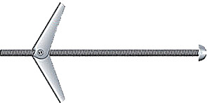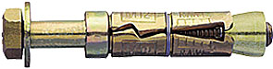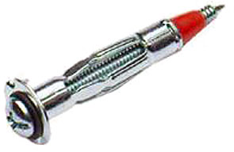

388.0

(2x)

388.0

(2x)

356.0

356.0

356.0

452.4

(2x)

450.3

Not in scale

All measurements in mm

57.6

36.8

32.1

(2x)

32.1

(2x)

Wallbox’s outer edge

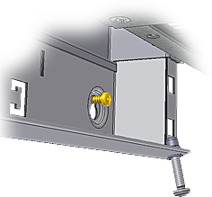

S4

S5

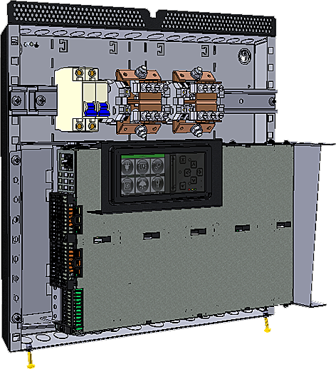

Wallbox’s Rear Plate

1

Keyhole



(x2)

2

1

2

S4



Suitable screw or bolt, S6 (x2)

3



cw

S7

(2x)



3

(x2)



4

4



PZ2

cw

Fixing the Wallbox B:1-4

Preparing the Wall A:1-2

A-B Fastening the Wallbox



**CAUTION:**

* Mounted additional equipment is not to touch the rectifiers power rack when in its closed position

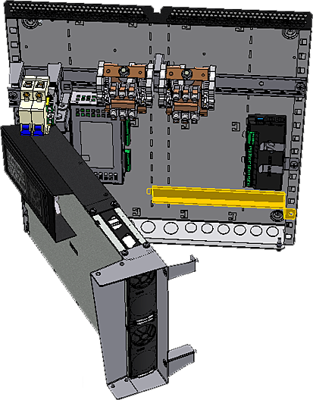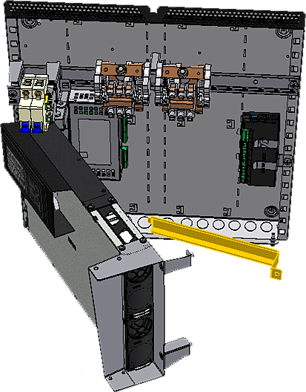

1

Wallbox’s Rear Plate

DIN Rail  
(for additional equipment)

Mounting Slots

Rectifiers Power Rack (open)

2

Wallbox’s Rear Plate

PZ2

(T2)

3

cw



M6

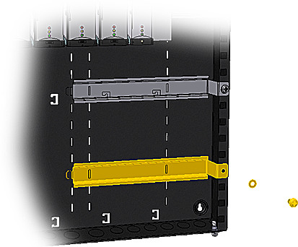

Smartpack2  
Basic Controller

I/O Monitor2  
Unit

Smartpack2  
Master Controller

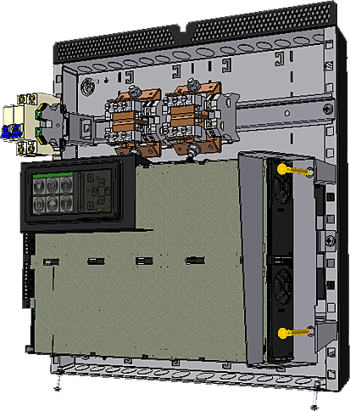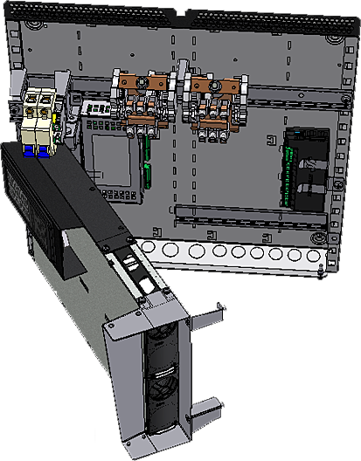

M6x50

PZ3 (2x)

(T2)

1

ccw



2

Wallbox’s Rear Plate

Wallbox’s Rear Plate

Rectifiers Power Rack (open)

Mounting DIN Rails (optional) B:1-3

Opening the Rectifiers Power Rack A:1-2

Mounting DIN Rails (optional) A-B

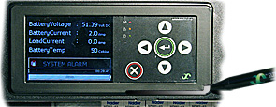

*Smartpack2 Master* controller (locked)

Handle in locked position

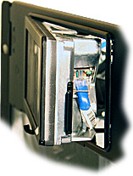

*Smartpack2 Master* controller (open)

Handle in open position

SD card

1

2

1

**Opening** the controller

**Closing** the controller

Pen, or use your fingers

Ethernet socket

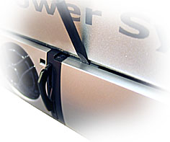

Screwdriver   
to release the locking tabs

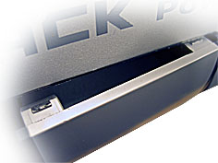

Blind panel’s upper locking tabs

1

2

1

1

2

Blind Panel

**CAUTION:**

Mount **blind panels** in unused rectifier locations.



**Removing** Blind Panels

**Mounting** Blind Panels

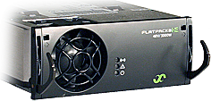

Flat 6mm

1

Handle   
in unlocked position

*Flatpack2 HE* rectifier

2

3

Hole to release the handle’s spring mechanism

1

3

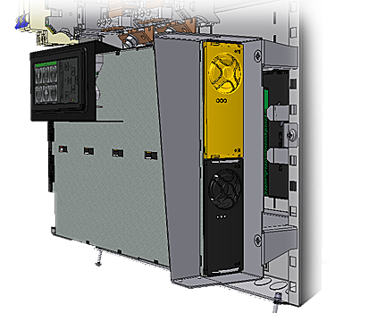

Wallbox’s Rear Plate

Handle in locked position

*Flatpack2 HE* rectifier

**CAUTION:**

The rectifiers may be warm, but **do not hand-carry them** by their handles. **Open the handles before inserting** them into the power shelves (hot-pluggable).



Opening and Closing the Smartpack2 Master Controller C:1-2

Mounting and Removing Blind Panels B:1-2

Mounting and Removing Flatpack2 Rectifiers A:1-3

A-C Installing Rectifiers & Opening the Controller

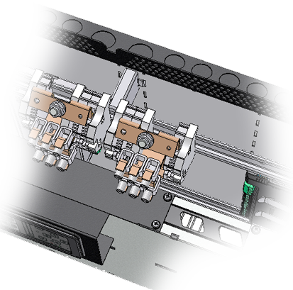

Top Cable Entries

PG29 x2 and PG21 x12

AC Mains MCBs

DC Output  
Bulk Feed

Chassis Earth   
Connection Screws (PE)

M5 x2

Cable fastening tabs

Bottom Cable Entries

PG29 x2 and PG21 x12

Wallbox’s Rear Plate

3

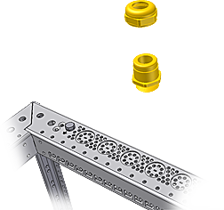

cw

2

Insert cable



cw

4

AW

(T5)

AW

(T5)

PG   
cable gland

1

Twist off and remove knockout plate

Knockouts (x12x2)

For PG21 cable glands (T5)

Knockouts (x2x2)

For PG29 cable glands (T6)

**NOTICE:**

Cable entries may be implemented with Thorsman TET grommets, PG cable glands or similar (not included)



PG Cable Gland



Thorsman   
TET grommet

Cable Entries, Knockout Plates, Cable Fastening, Chassis Connections 1-4

Cable Management



5

Insert and connect  
“+”&”–“ DC Load cables

(E & F)

E

F



PG   
cable gland

3

Insert and connect   
“L”&”N” AC Mains and “PE” Earth cables

(A & B)



A

B

Wallbox’s Rear Plate

6



Insert and connect  
I/O signal cables and Ethernet cable

(C & D)

C

D

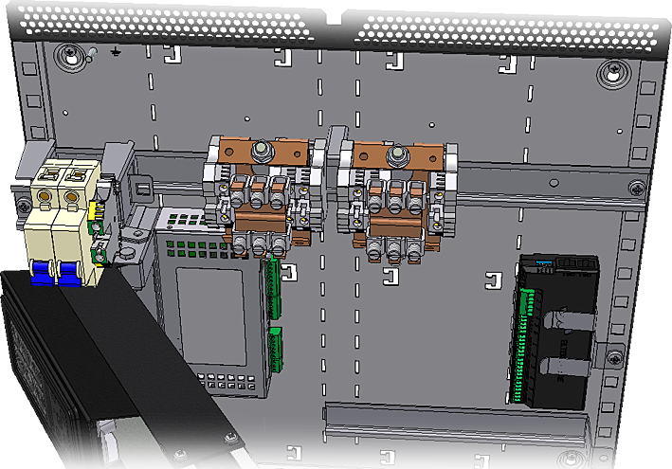

Earth Terminal (PE)

Max 10mm2 (6awg)   
(T2)

AC Mains Input

Max 25mm2 (2awg)   
(T2)

AC Mains MCBs  
(internal) 32 A

N

L

Chassis Earth   
Connection Screws (PE)

M5 x2

Cable fastening tabs

DIP Switches

I/O Monitor2 Unit

Configurable Inputs

X*** Max 1.5mm2 (14awg)

Input 6

Relay Outputs

X**** Max 1.5mm2 (14awg)

Relay 1

Smartpack2 Basic controller

Temp. Sense Inputs

X** Max 1.5mm2 (14awg)

1+

+

–

Ethernet socket

1

Switch OFF   
external AC Mains MCBs

**NOTICE:**

For more information about signal and pin-out terminals (X***), refer to Schematics, page 3



2

Switch OFF   
internal AC Mains MCBs

4

Switch OFF   
external Load MCBs

DC Load “–”

M8 bolts (T1)   
Cable Lugs diam. 8.5mm, Max. 10.5mm

DC Load “–”

*Screw Terminals* *35 mm2,(* 1awg*)* (T1)

DC Load Terminal Rail

(To be removed in 110VDC systems)

7

Fasten all cables

(A & F)

**CAUTION:**

**Before** connecting the DC Load cables in **step 5**, ensure that if the Wallbox is using ***110VDC Flatpack2*** rectifiers (241115.805), you must always first remove the DC load terminal rails — with the M8 bolts and screw terminals — and connect the load to the WDU terminal blocks, as explained in section B, page 10.



|  |  |  |
| --- | --- | --- |
| Current Max. | **Ext. Fuse** | **Ext. Fuse** |
| AC input (A)  205VAC 185VAC | **Type Th/Mag**  205VAC 185VAC | **Type Hy/Mag**  205VAC 185VAC |
| 21.5 24.0 | ← **25A-D** → | ← **25A-C2** → |

Doc 2020432,3v0

Recommended External AC Fuses  
**Flatpack2 Wallbox ~ Systems with 2000W Rectifiers**

* Use the values in the 185VAC column,   
  if you are unsure or know that the available AC mains voltage may drop below 205VAC
* The recommendations ap­ply for use of   
  – Thermal mag­netic circuit breaker (Th/Mag), type Siemens 5SX or 5SY se­ries, MG C60H series or similar; and  
  – Hydraulic magnetic breaker (Hy/Mag), type CBI QF frame or QY frame, Airpax or similar

**For installations in USA and Canada only!**

– The installation has to comply with the NEC/CEC requirements

– The power system must be equipped with branch circuit protection that complies with NEC/CEC requirements and have a rating at minimum 32A

– For supply connectors, use wire suitable for at least 75ºC (167ºF), type: FEPW, RH, RHW, THHW, YHW, THWN, ZHHW, USE, ZX or similar. Use copper conductors only

**UL Approved System Ambient Temperatures**

with Specified DC Cables and DC Load Breakers

|  |  |  |
| --- | --- | --- |
| System’s Ambient Temp | DC Cables’ Temp Rating | DC Load  Breaker |
| Max. 50°C | 60°C, Cu wire** | Max. 15A |
| Max. 50°C | 75°C, Cu wire | Max. 20A |

** Default UL approved DC cables



PZ2



IW

Flat

Connecting AC Main Input, DC Output and I/O Control Signals A:1-7

A-B Electrical Connections

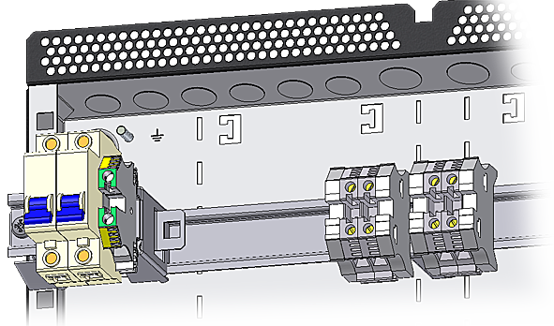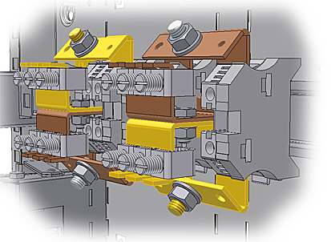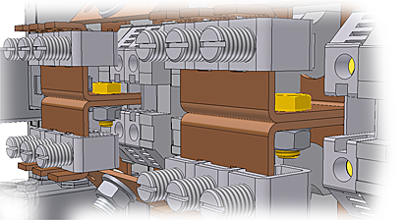

“–” DC Terminal Rail 3

“–” DC Terminal Rail 4

“+” DC Terminal Rail 1

“+” DC Terminal Rail 2

Terminal rails fastening bolts “B3”&”B4”

WDU terminals   
(for rail fastening)

1

Unscrew internal “+” & “–” DC Output cables (4x) from the terminal rails

2

Unscrew and remove both terminal rails fastening M6 bolts, B1, B2, B3 & B4

4

Connect the internal “+” & “–” DC Output cables (4x) to the WDU terminals

5

Connect the external “+” & “–” DC Load cables to the WDU terminals

Wire Section 10 mm2 (6AWG)

Terminal rails fastening bolts “B1”&”B2”

M6 bolt “B2”

M6 bolt “B4”

3

Unscrew the WDU terminals (2x2) and remove the terminal rails 1, 2, 3 & 4

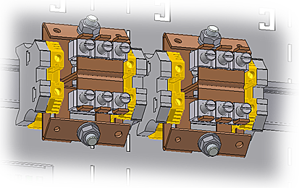

WDU terminals   
(for rail fastening)

E

F

Internal “+” & “–”   
DC Output cables (4x)



IW

Flat

Flat

Flat

Flat

Connecting the Load in 110VDC Power Systems B:1-5

Electrical Connections A-B



*This page has intentionally been left empty*

PULLOUT

Check Lists Pullout

Pull out the pages with the gray outer band,   
and use them as check lists

Instructions to create the PDF publication with the *Pullout Section* in the middle, between pages 6 and 7 (12/2):

1. Create the PDF file from the Word document
2. In Adobe Acrobat:  
   - Rotate pages 13 through 16, 180 degrees  
   - Move pages 13 through 16 in between pages 6 and 7  
   - Save the PDF file

Form 178-gb-v1-C01_354034-103_1v0

**commissioning procedure**

System Data *Flatpack2 Wallbox PS System*

|  |  |  |  |  |
| --- | --- | --- | --- | --- |
| Supplier’s Order No.: | *Flatpack2 Wallbox Power Supply System*, type: | | | Article No.: |
| Site, name: | | | | |
| Serial No.: | | Software, version No.: | | Rectifiers, type & number of: |
| AC Input Voltage, measured: | | Battery Type, if applicable: | Battery Capacity: | Commissioning carried out by, name: |

Pre-Start Check Power is OFF!

|  |  |
| --- | --- |
| **check following:** | **ok** |
| 1. Flatpack2 Wallbox system installation is completed;   All cabling is securely terminated with correct polarity | 🞏 |
| 1. All external load MCBs/ fuses are switched OFF | 🞏 |
| 1. AC input cable(s) and AC earth wire (PE) are terminated | 🞏 |
| 1. Site specific parameters and settings are known | 🞏 |
| 1. AC supply and all external and internal MCBs/ fuses are switched OFF | 🞏 |

Start-up, No-Load & Load Adjustments Power is ON!

|  |  |
| --- | --- |
| **carry out following:** | **ok** |
| 1. Disconnect all rectifier modules, without removing them (keep original location) | 🞏 |
| 1. Switch ON the system (external and internal AC MCBs/fuses ON) | 🞏 |
| 1. AC input voltage is correct; Measure and verify | 🞏 |
| 1. Insert all *Flatpack2*rectifiers in their original locations in the power rack | 🞏 |
| 1. The *Smartpack2 Master* and all rectifier modules are working, LEDs are ON; Verify | 🞏 |
| 1. Connect a PC to the PS system Use a standard Ethernet cable and access the controller | 🞏 |
| 1. DC output voltage; Measure and adjust | 🞏 |
| 1. Alarm relay test; Verify all alarm relays are working correctly | 🞏 |
| 1. System Setup is in accordance with configuration Enter site spec. info via front keys or PC | 🞏 |
| 1. Connect all external load MCBs/ fuses, and verify no alarms are displayed | 🞏 |

Approval

|  |  |  |
| --- | --- | --- |
| Responsible of commissioning, sign.: | Date: | Approved by customer, sign.: |

I

II

Device  
Hazard



Device  
Hazard



PULLOUT

www.eltekvalere.com

|  |  |
| --- | --- |
| Headquarters: **Eltek Valere** Gråterudv. 8, PB 2340 Strømsø, 3003 Drammen, Norway Phone: +47 32 20 32 00 Fax: +47 32 20 32 10 |  |



PULLOUT

*This page has intentionally been left empty*

Instructions to create the PDF publication with the *Pullout Section* in the middle, between pages 6 and 7 (12/2):

1. Create the PDF file from the Word document
2. In Adobe Acrobat:  
   - Rotate pages 13 through 16, 180 degrees  
   - Move pages 13 through 16 in between pages 6 and 7  
   - Save the PDF file

Check Lists Pullout

Pull out the pages with the gray outer band,   
and use them as check lists

PULLOUT